**A New Family**

**Readings:** John 1:12

Some people did accept him. They believed in him, and he gave them the right to become children of God.

1 John 3:1

The Father has loved us so much! This shows how much he loves us: we are called children of God. And we really are his children.

**Thought about the readings**

Everyone belongs to a family and has a family name. It is called a ‘surname’ and it tells people which family you belong to. My family name is ‘Cole’. It tells people that when I married my husband Mike, I become part of the Cole family. Before I married him, my surname was Roberts which meant that I belonged to the Roberts family.

The two readings this week are both written by John, one of Jesus’ special friends. He wrote that when people accept Jesus, when they decide to follow him, they become part of a new family. They become part of the family of God.

If you have decided to follow Jesus, then you are part of God’s family. You are a child of God. God is your Father and Jesus is your big brother. Other people who follow Jesus are also your brothers and sisters.

Some families are not happy, but in God’s family you will always be loved and safe because God your Father is looking after you.

**Prayer**

Father God, thank you that when we choose to follow Jesus, you give us the right to become your children and part of your family. Thank you that you did this because you love us so much.

Thank you for our brothers and sisters who live in Cambridge, in Britain and all over the world. May they all know how much you love them.

Amen

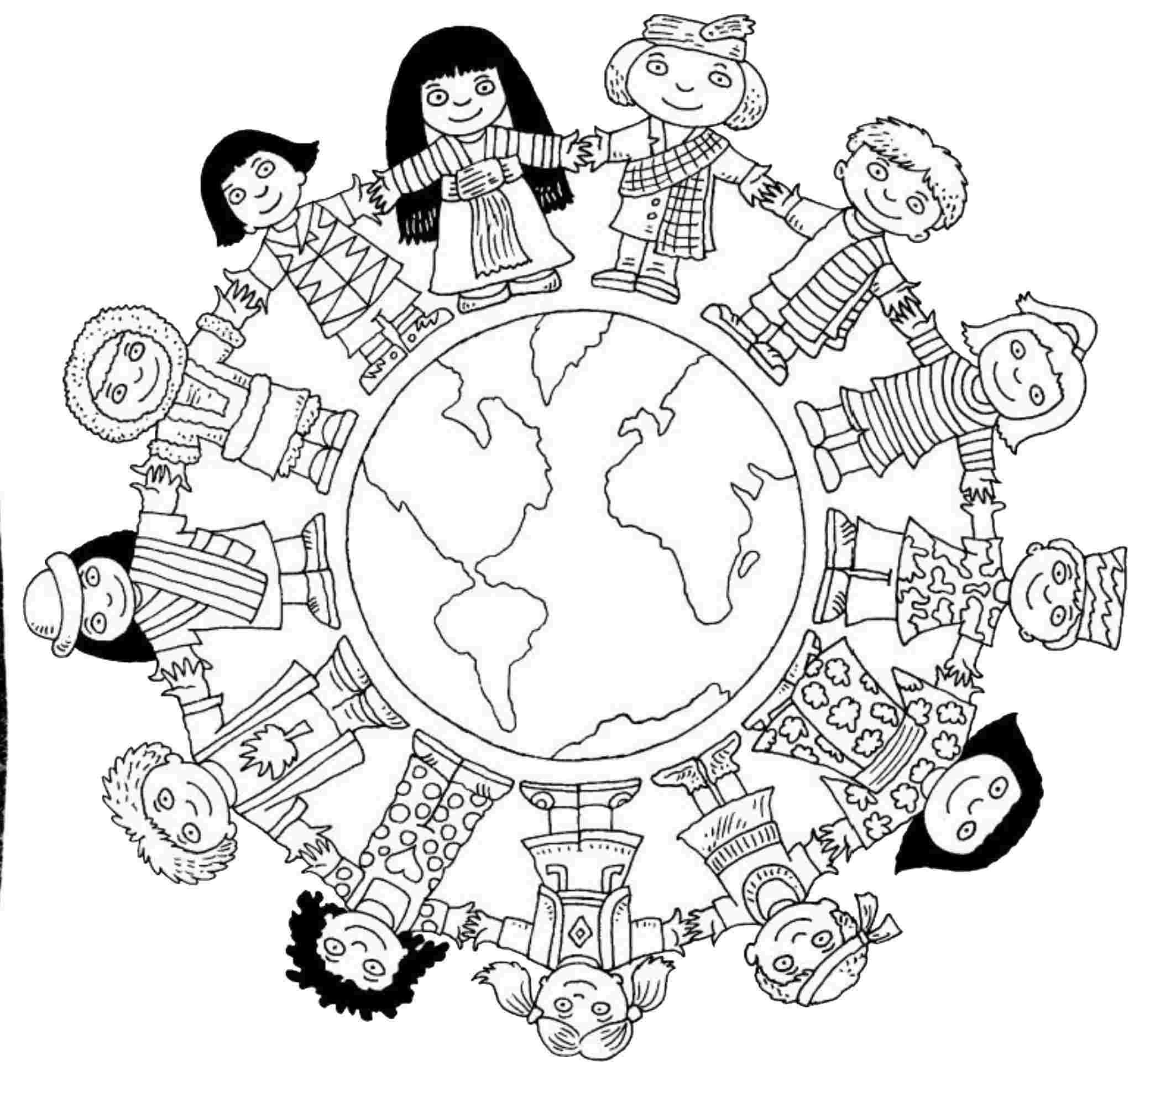

When we decide to follow Jesus, we become part of a family with brothers and sisters all over the world.

**Cambridge Causeway**

Spring 2021

Bible Study notes

**All Things New:**

**A New Family**

By Chrissy Cole